## Firstly I have used the following query to get the required data from MYSQL.

In the query, i have table Orders with orderdetails, products, productline, customers, payments, employees and office.

After that, i have exports the csv files and load into the Power BI to get car sales insights.

The SQL query is as follows:

select

o.orderDate,

o.shippedDate,

o.ordernumber,

o.status,

o.customerNumber,

/*od.productCode */ /*--optional */

od.quantityOrdered as Qty,

od.priceEach,

p.productCode,

substring(p.productDescription,1,10),

p.productName,

p.productLine,

p.MSRP,

p.quantityInStock ,

pl.textDescription,

c.customerName,

c.country,

c.creditLimit,

c.addressLine1,

c.state,

c.salesRepEmployeeNumber,

p2.paymentDate,

p2.checkNumber,

p2.amount,

emp.firstName,

emp.lastName,

emp.jobTitle,

off.addressLine1,

off.city,

off.country

from orders o

inner join orderdetails od on o.orderNumber=od.orderNumber

inner join products p on p.productCode=od.productcode

inner join productlines pl on pl.productLine=p.productLine

inner join customers c on c.customerNumber=o.customerNumber

inner join payments p2 on p2.customerNumber=c.customerNumber

inner join employees emp on c.salesRepEmployeeNumber=emp.employeeNumber

inner join offices off on off.officeCode=emp.officeCode

/*WHERE c.customerNumber = 448 */

/* P.productCode IN ('S12_3148', 'S12_4473') */

Dashboard Details

1. Here i have made the first layout describing the Sales of car based on Product lines.
2. In 2nd layout , i have shown cards having total sales and the Profit achieved.
3. In 3rd layout , i have shown slicers where Customer country details are shown and Orders based on Date hierarchy is shown.
4. In 4th layout showing how many orders per customer.
5. IN 5th layout shows the count of Products corresponding to each productLine.
6. Here, tree map shows the Orders count based on ProductLines.
7. Here, Chart shows Inventory of products based on each ProductLines.

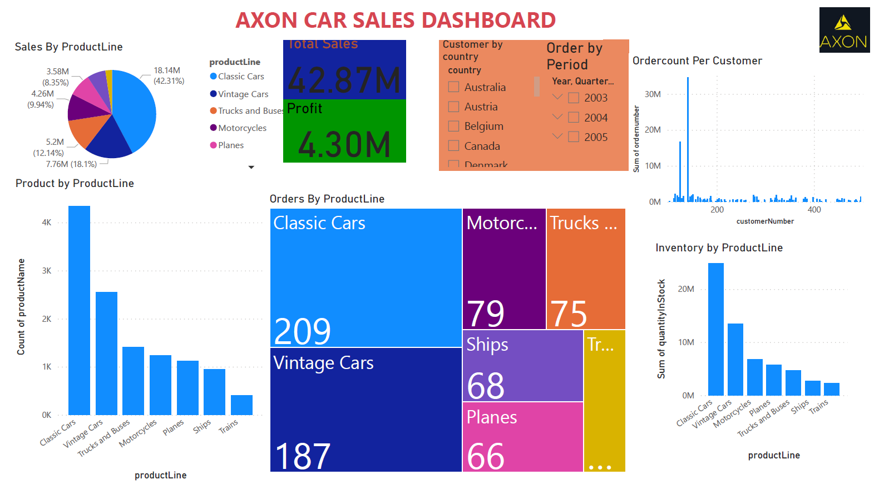

1. Here Card shows Total employees, total orders, Total Products and ProductLines.
2. 2nd layout shows the product lead time by plotting the Order date vs Shipped date.
3. 3rd layout shows the Status of different products

